LIGHT AND HEAT STUDY GUIDE
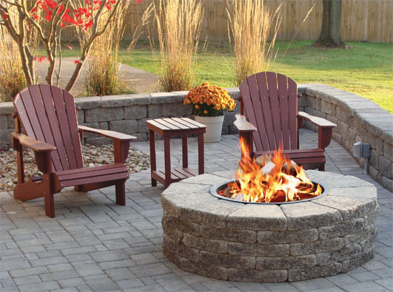
Use the picture above to answer questions 1-3
- If you were to sit in the chairs near the fire pit, you would feel the warmth of the fire, why is this? What type of heat transfer is occurring?
- If you were roasting a marshmallow above the fire what type of heat transfer is occurring as the marshmallow cooks? (HINT: your marshmallow is in the AIR)
- If while roasting marshmallows, you decided to use a metal stick instead of wood and you burned yourself, what type of heat transfer occured?
- What is a conductor? Give 3 examples of conductors.
- What is an insulator? Give 3 examples of insulators.
- Why does Starbucks use paper cups for their hot coffee and not metal cups?
- Explain what happens to a pot of water as it begins to boil.
- Explain the changes that happen to an ice cube when heat is added to it.
- Which travels faster sound or light?
- When does heat transfer stop?
- Why does an apple appear red?
- As you go from left to right on the electromagnetic spectrum, what happens to the wavelengths? Frequency? Energy?
- How does the Suns energy get to Earth?
- What is reflection? Give an example of reflection.
- What is refraction? Give an example of refraction.
- What is absorption? Give an example of absorption.
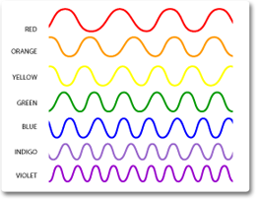
- Which wave above has the longest wavelength? Shortest wavelength?
- Describe how a rainbow forms.

